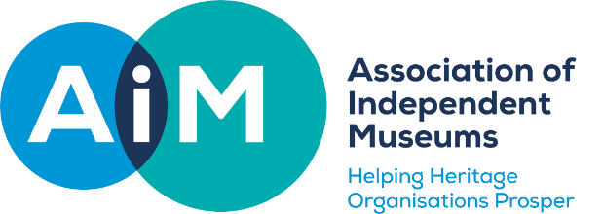
AIM Selection Monitoring Questionnaire
Please mark with X all that apply.
1. How do you describe your ethnicity?
White British
White Irish
White Gypsy or Irish Traveller
Any other white background
Mixed: white and Black Caribbean
Mixed: white and Black African
Mixed: white and Asian
Any other Mixed/Multiple ethnic background
Asian/Asian British: Indian

Asian/Asian British: Pakistani

Asian/Asian British: Bangladeshi
Asian/Asian British: Chinese
Any other Asian Background
Black/Black British: African
Black/Black British: Caribbean
Any other Black/African/Caribbean background
Arab
Prefer not to say

2. Disability status
Disabled: Visual impairment/Blind
Disabled: Hearing impairment/Deaf
Disabled: Physical impairment
Disabled: Mental health
Disabled: Invisible disabilities
Disabled: Cognitive or learning disabilities
Not disabled
Prefer not to say

3. Gender identity
Male (including female to male trans men)
Female (including male to female trans women)
Non-binary (for example, androgyne people)
Prefer not to say
4. Gender assumed to be at birth
Male
Female
Prefer not to say
5. Sexual orientation
Prefer not to say
Lesbian, Gay and Bisexual
Heterosexual
Other

Please send your completed form in confidence, separately to your application, to aimadmin@aim-museums.co.uk

