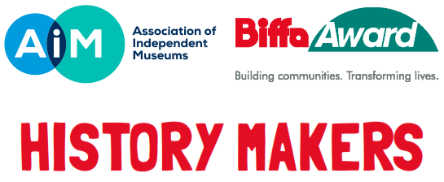
HISTORY MAKERS – PEOPLE WHO SHAPED OUR WORLD
EXPRESSION OF INTEREST (EOI) INFORMATION

WHAT IS AN EXPRESSION OF INTEREST?

The submission of this Expression of Interest (EOI) form is the first step in applying for AIM Biffa Award History Makers funding. This is your chance to advocate for your History Maker or Makers and will ensure your time is not spent on an application that cannot proceed. You can submit an EOI form even if you only have an outline idea of how your project will develop but know who your History Maker is. You should submit an EOI as early as possible to allow for a panel decision in order to move to the History Makers application stage. This will also give you the required time to develop your project, communicate with AIM project staff and submit your application.

WHAT MAKES AN AIM BIFFA AWARD HISTORY MAKER?

- We are looking for projects that use the life and achievements of extraordinary historical figures to inspire and educate your visitors and users today.
- Your History Maker may not be a well-known public figure, but most importantly their life and/or work will have helped shape the world we live in today.
- Figures whose impact was only significant at the time would not be eligible.
- People are making history all the time, so we are happy to receive expressions of interest for History Makers from any period, including more recent history.
- We are particularly keen to hear from projects based on women who made history and history makers from diverse backgrounds.
- Change can be the result of collective effort as much as that of individuals, so we are also happy to hear about projects that tell the story of how distinct groups, teams or partnerships have made history.
- For multiple History Makers we would expect the majority of the group members to be named and identified. If the group had a clear leader or figurehead, that person would most likely be the focus of your application.
- There should also be a clear link between your chosen History Maker (s) and your museum site, story, or collection. It needs to make sense that you be the location to tell their story.
- You can simply complete and submit this form with details of your History Maker and we will contact you to let you know if you have been approved to move forward to application stage
- Or if you have a possible History Maker in mind and are uncertain if they would be suitable, have any questions about the scheme, are looking for advice or would like to talk to us about your project ideas, please do get in touch by

Emailing Justeen@aim-museums.co.uk or
Phoning 0333 305 8060

Please do remember that there are other application criteria that need to be met as well as the status of your chosen History Maker to be eligible for funding.
See Application Guidance for full details.
Note: the acceptance of your EOI at this stage is not a guarantee of future funding.

THE EXPRESSION OF INTEREST PROCESS
- Submit the EOI by Email to Justeen Stone, AIM Programmes and Finance Officer justeen@aim-museums.co.uk
- Your EOI will be acknowledged by email return and logged for review.
- The EOI’ s will be submitted to the review panel on a weekly basis.
- The AIM History Makers team will contact you after the outcome is known (please allow 12 working days from the point of submission).
- You will be advised if your History Maker and project is eligible for full application.
- The panel do sometimes request further information to support the decision-making process, if so, you will be contacted with the request detail.
- If your EOI is approved by the panel to proceed to application stage the AIM team will be able to advise you about how well it fits with the aims and assessment criteria for History Makers. We will be on hand to work with you to develop your project application, in line with required Landfill Communities Fund regulations.
- If your EOI is not approved to proceed to application, the AIM team will advise you and provide any feedback given by the panel.

CLOSING DATE FOR EXPRESSIONS OF INTEREST – 5 P.M. MONDAY 14th DECEMBER 2020
CLOSING DATE FOR FULL APPLICATIONS – 5 P.M. SUNDAY 28th FEBRUARY 2021

HISTORY MAKERS – PEOPLE WHO SHAPED OUR WORLD
EXPRESSION OF INTEREST (EOI) FORM FOR COMPLETION
Name of organisation
AIM Membership No.
Who should we contact regarding this EOI?
Name
Role in organisation
e.g. Committee Member, Secretary.
Postal address

Postcode
Daytime Tel. number
Email address
We use email where possible. Please ensure this email is checked regularly.
Project Location
Address and postcode
History Maker
Please tell us about your History Maker/s in no more than 200 words:
Tell us about their international, national or regional importance and the significance and impact of their life or work in shaping our world today. What is their legacy?

Project Description
In no more than 200 words, what are your outline ideas for how you will tell the story of your History Maker, including any initial plans for interpretation?
Office use only Approved eligible for full application. Yes/No Date

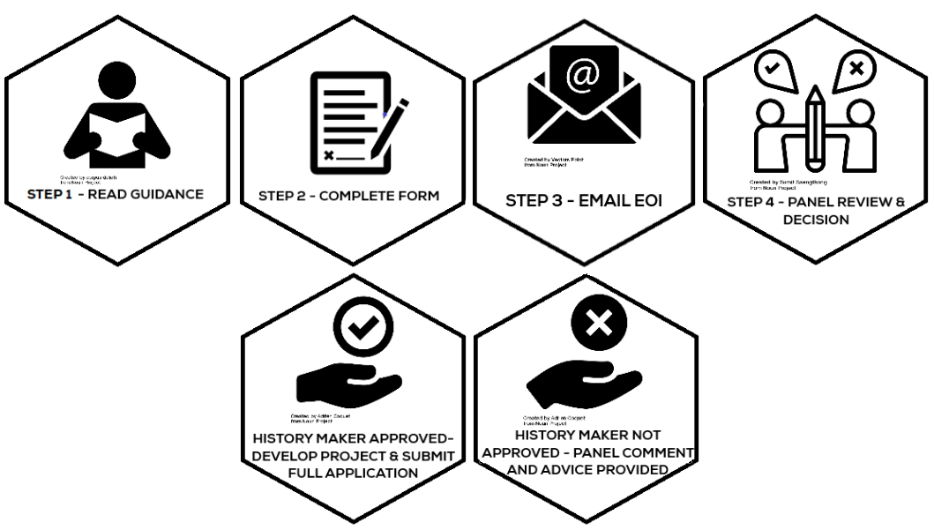

FUND INFORMATION
AIM
AIM administers the programme on behalf of Biffa Award and all queries should be directed to AIM. We welcome applications from AIM members to become part of this exciting new national scheme. Please note we cannot accept applications from members within Scotland and Wales, as the Landfill Communities Fund, which provides the funding for this scheme, is devolved in these regions.

RSWT
Biffa Award is managed by the Royal Society of Wildlife Trusts. RSWT has a dedicated grants team that manages several different funds, covering broad environmental themes. The team does this on behalf of organisations, such as Biffa Group Limited, European Union, The National Lottery Community Fund and Network Rail.

LANDFILL COMMUNITIES FUND
The Landfill Communities Fund (LCF) is an innovative tax credit scheme enabling landfill operators (LOs) to contribute money to organisations enrolled with ENTRUST as Environmental Bodies (EBs). EBs use this funding for a wide range of community and environmental projects in the vicinity of landfill sites. Since its inception in 1996, over £1.6 billion has been spent on more than 56,000 projects across the UK. For further information please visit the Entrust website.

