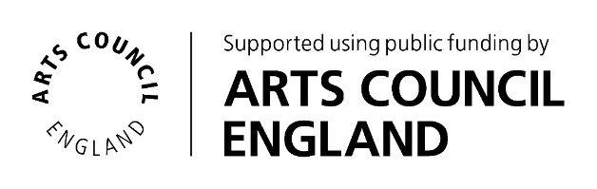
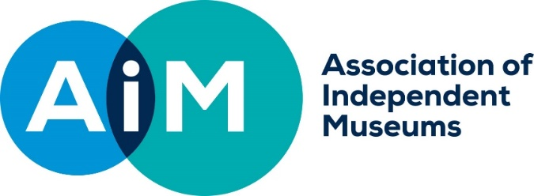

AIM Hallmarks Grants
Application form, October 2020-2021

Legal name of museum (beneficiary of grant)
Legal name of applicant organisation (if not the beneficiary of grant)
Project leader
Role/Title within museum
Email
Phone
Address if different from above
Bank Account Name
Bank Account Sort Code
Bank Account No. (Preferred payment method is by BACS)
VAT Registration No. (if your organisation is VAT Registered, you should exclude VAT when outlining your project costings)
AIM membership number
Accreditation Status/Number
Working Towards Accreditation | Expected Date for achieving Accreditation
Number of days open to the public in the last calendar year
Annual visitor numbers last year

About your project

What is the title of your project?
Please give a brief headline description of your project and its aim (up to 25 words).
Use this box to sell your project to the awards committee.

What is the total cost of your project?
How much funding are you applying for?
Where will the balance come from, if applicable? If expected income, please advise when this will be?
Outline project plan and timetable (up to 800 words): provide a brief overview of your project delivery plan, including when you expect to start and complete it, and outline the key stages or milestones involved.

Key assessment information
The grants committee will score your proposal against each of the criteria according to the answers you give here. They will also include a score for the overall quality of your proposal and how well you demonstrate your ability to plan and deliver a successful project.

  - Link to the AIM Tackling Inequality Hallmark (up to 500 words): explain how the project links to the AIM Tackling Inequality Hallmark.
Type your answer here

  - Opportunity (up to 300 words): Demonstrate how your museum has reviewed its strengths and challenges in order to develop its plans and explain how the proposed work is linked to the organisation’s strategic priorities.
Type your answer here

  - Impact (up to 300 words): how will the work funded change the organisation at a strategic level? Is it clear that it represents a new way of working for that organisation?
Type your answer here

  - Value for money (up to 300 words): provide a project budget and demonstrate that it represents good value for money.
Type your answer here

Please specify up to three outcomes for your project that you will report against in your evaluation report. |  | 1.
 |  | 2.
 |  | 3.
The Chair or Vice Chair of Trustees should sign below. If submitting electronically, a typed name is sufficient, we will require a hard copy signature on the acceptance form for successful applicants.

I confirm that to the best of my knowledge all the information in this application is true. I declare that I am authorised to make this application and I accept the terms and conditions listed in the guidelines. I accept that AIM may share application information with the relevant local Museum Development Team or similar organisation.

Signed
Full Name
Job Title or Role
Date

Mandatory enclosures:

Your application needs to include:
- a completed application form
- the project budget
- current museum budget
- most recent annual accounts and report
- a minimum of one hi resolution image (Where possible, send us an image which tells us something about the work proposed. Otherwise, choose an image which helps the
panel understand what your museum is like. AIM may use these images to help publicise the funding programme in future.)
- a link to your museum website or other marketing materials

Applications should be sent digitally to Justeen Stone, AIM Programmes and Finance Officer, by 5pm on 31 January 2021.
justeen@aim-museums.co.uk t: 0333 305 8060

