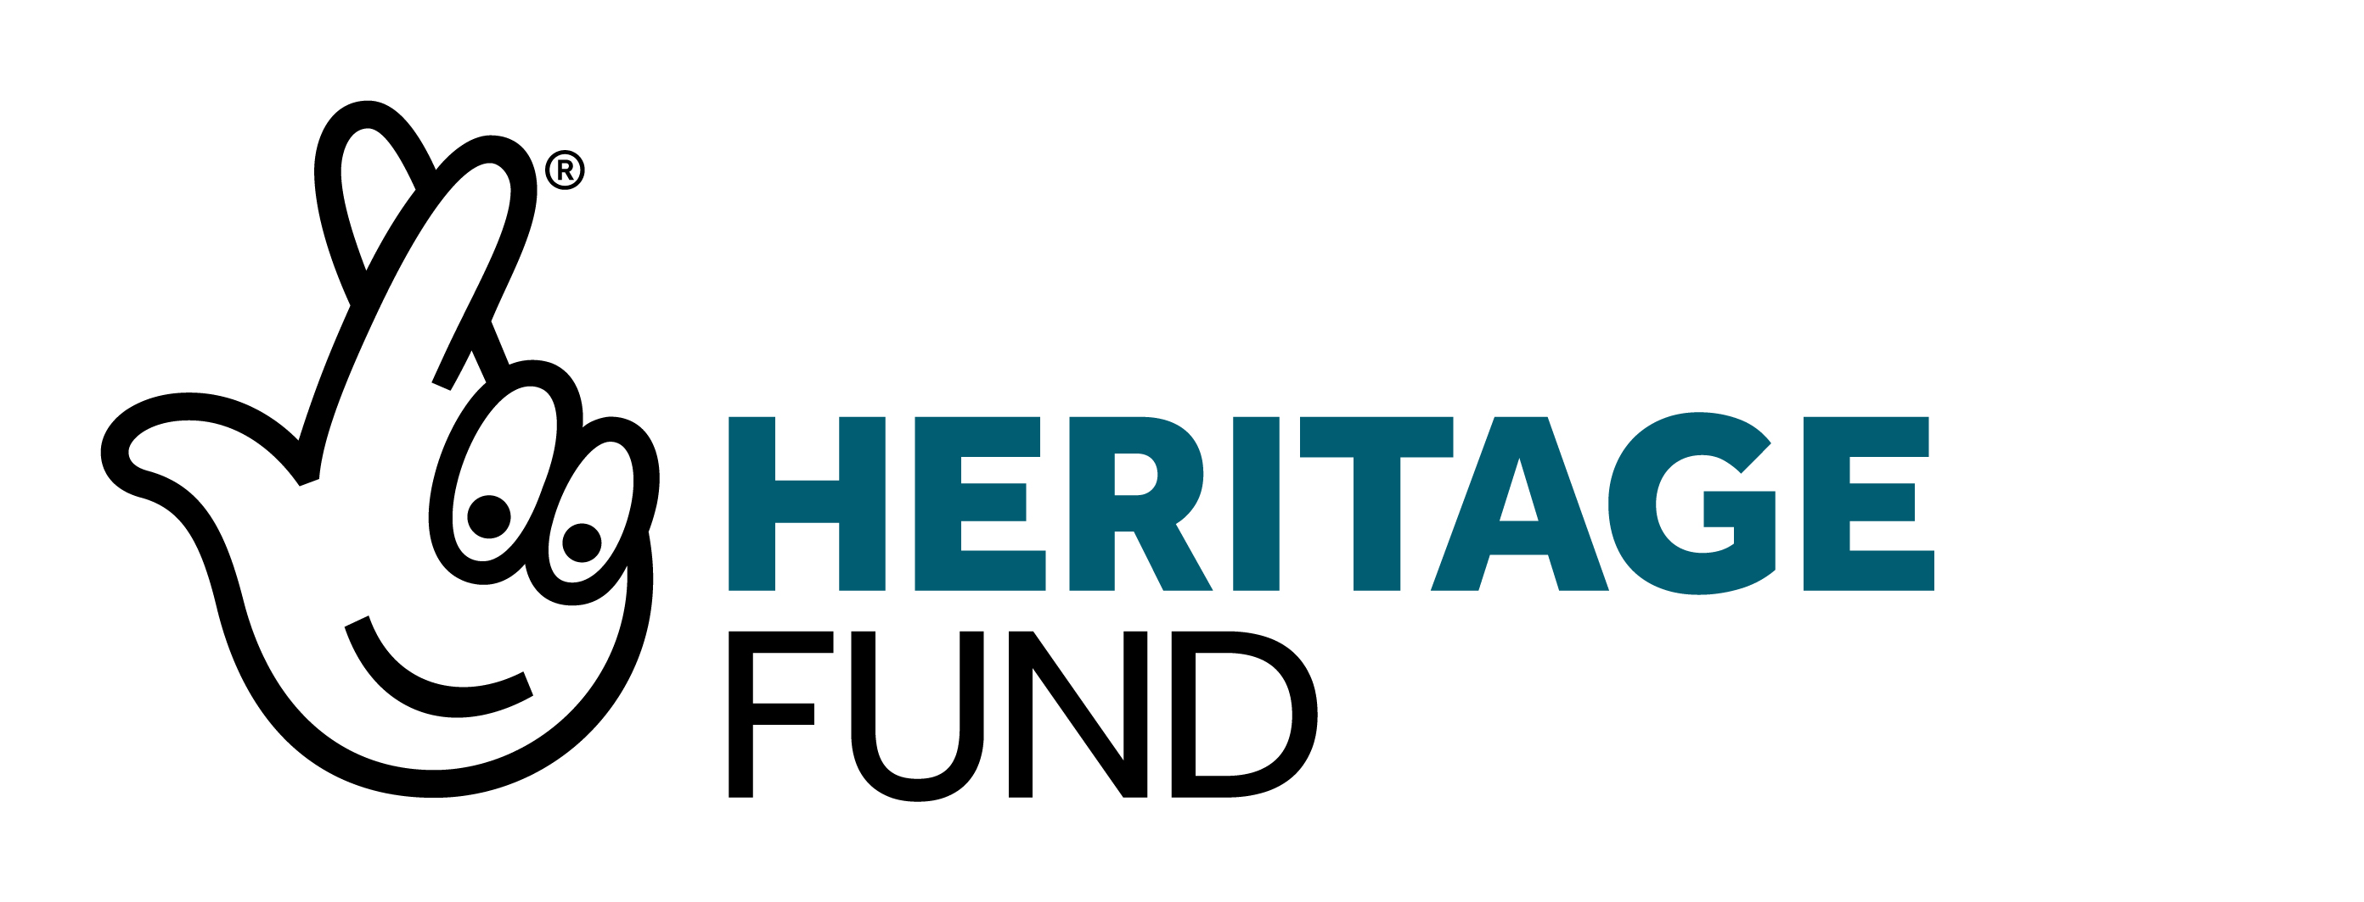
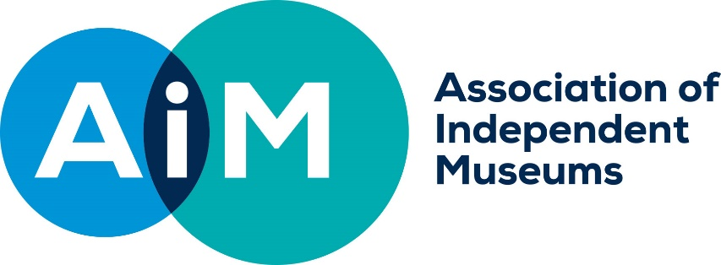

AIM NEW STORIES NEW AUDIENCES
APPLICATION FORM

- ABOUT YOUR ORGANISATION (SEE APPLICATION GUIDANCE SECTION 2)

Legal name of museum (Beneficiary of Grant)
Is this your organisation’s first application to us?
Project Leader
Role within museum
Email
Phone
Organisation address
Bank Account Name
Bank Account Sort Code
Bank Account Number
AIM Membership Number
Legal Status of Organisation:
Annual Turnover | £
Have you received any advice from us before making your application?
If your project involves buildings, land, or objects, do you own these outright? (see guidance notes section 13 on ownership requirements) | If you are not the owner tell us what agreement you have with the owners to undertake the works.

2. YOUR PROJECT (SEE APPLICATION GUIDANCE NOTES SECTION 3)
What is the title of your project?
Please give a brief headline description of your project (Up to 100 words)
Describe your project (up to 300 words)
Please tell us what you will do, who will be involved, what you will be spending the funding on

How will your project meet the grant criteria? (up to 500 words).
Please tell us:
- what is the new story you wish to tell
- what initial research you have undertaken to identify who the new audiences will be
- who the new partner is that you will work with
- how you will work differently and try something new.

Which of our priorities does your project support?
Your project must achieve the first outcome and one other. (See application guidance notes section 5)
Please tell us how your project will do this. (Up to 200 words)
When will your project start and finish? (Where possible you should aim to start your project within one month of being awarded a grant. Your project should finish in 12 months.)
Start date: 00/00/2021
Finish date: 00/00/2021
What will you do to ensure your project is environmentally friendly? (See application guidance notes section 6. Up to 200 words)
3. MANAGING YOUR PROJECT (APPLICATION GUIDANCE NOTE SECTION 3)
How will you manage your project? (Up to 300 words)
Please tell us about:
- the skills and experience of the person who will lead your project
- the people in the project team
- identify any training that will be necessary for or will improve the delivery of the project, whether staff, volunteers, or local communities,
- What will happen to the resulting physical and digital project outcomes produced after the funding ends? For example, the exhibition interpretation, panels, replicas etc.
4. COSTS OF YOUR PROJECT (APPLICATION GUIDANCE NOTE SECTION 9)
What is the total cost of your project?
What are the costs of your project?
The value in the cost column should be the cost including any VAT that cannot be recovered.
Activity or Purchase Description | Cost including Irrecoverable VAT | Total

Tell us how you calculated your costs and how you know they are realistic? E.g. they are publicly advertised costs and can be evidenced, you have obtained quotes, or you have paid for similar work in the past. (Up to 200 words)
How much funding are you applying for?
How will you provide your 5% contribution?
5. SUPPORTING DOCUMENTS (SEE APPLICATION GUIDANCE NOTES SECTION 10)
- A copy of your charitable incorporated organisation (CIO) foundation or association constitution (for CIOs). The memorandum and articles of association (for charitable companies), trust deed or will (for trusts).
- A copy of recent accounts
- Briefs for externally commissioned work over £10,000
- Letters of support
- Images
6. DECLARATION
- I have read, understand, and accept the notes that came with this application form. I agree that you can check the information in it and any supporting documents with other people and organisations.
- My organisation has the power to accept a grant, under your terms, and the power to pay back the grant if the terms are not being met.
- I understand that any misleading statements (whether deliberate or accidental) I give at any point during the application process, or any information I knowingly withhold, could mean my organisation’s application is not valid, in which case you will cancel the grant and claim back the money we have received, stop assessing and return the application, or withdraw any grant you offered my organisation.
- I am authorised to put forward this application on behalf of my organisation.
- On behalf of my organisation, I agree that if we receive any grant from you for our project, we will keep to the standard terms of grant (and those of the National Lottery Heritage Fund as the origin of the funds) and any further terms and conditions set out in the grant notification letter.
Name:
Organisation:
Position:
Date:
Please send the completed form to: [address/email address].

