AIM CONFERENCE
DELEGATE BOOKING FORM

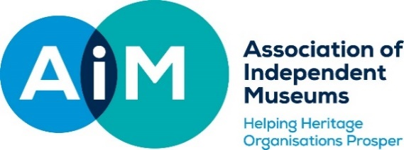
16-17 JUNE 2022, at Port Sunlight Village Trust
www.aim-museums.co.uk/conference

BOOKING FORM – DELEGATE INFORMATION
ORGANISATION NAME
1 DELEGATE NAME (as it will appear on badge)
EMAIL ADDRESS (included in delegate list)
ANY DIETARY REQUIREMENTS?
ANY ACCESS REQUIREMENTS?
POSITION
CONFERENCE COACH REQUIRED? PLEASE STATE YOUR HOTEL NAME
(Info on hotels can be found here: https://aim-museums.co.uk/aim-national-conference-2022/conference-accommodation/)
YOUR NAME & EMAIL ADDRESS INCLUDED WITHIN THE DELEGATE LIST? Y/N
HAVE YOU BEEN TO AIM CONFERENCE BEFORE? Y/N
2 DELEGATE NAME (as it will appear on badge)
EMAIL ADDRESS (included in delegate list)
ANY DIETARY REQUIREMENTS?
ANY ACCESS REQUIREMENTS?
POSITION
CONFERENCE COACH REQUIRED? PLEASE STATE YOUR HOTEL NAME
(Info on hotels can be found here: https://aim-museums.co.uk/aim-national-conference-2022/conference-accommodation/)
YOUR NAME & EMAIL ADDRESS INCLUDED WITHIN THE DELEGATE LIST? Y/N
HAVE YOU BEEN TO AIM CONFERENCE BEFORE? Y/N
3 DELEGATE NAME (as it will appear on badge)
EMAIL ADDRESS (included in delegate list)
ANY DIETARY REQUIREMENTS?
ANY ACCESS REQUIREMENTS?
POSITION
CONFERENCE COACH REQUIRED? PLEASE STATE YOUR HOTEL NAME
(Info on hotels can be found here: https://aim-museums.co.uk/aim-national-conference-2022/conference-accommodation/)
YOUR NAME & EMAIL ADDRESS INCLUDED WITHIN THE DELEGATE LIST? Y/N
HAVE YOU BEEN TO AIM CONFERENCE BEFORE? Y/N
CONFERENCE BOOKING REQUEST

WHOLE CONFERENCE
DAY 1 AND 2 £220
THURSDAY 16 JUNE 2022
AIM MEMBER STANDARD RATE £120
NON-MEMBER RATE £150
AIM THURSDAY EVENING SOCIAL EVENT AT THE LEVERHULME HOTEL £65 +VAT
FRIDAY 17 JUNE 2022
AIM MEMBER STANDARD RATE £120
NON-MEMBER RATE £150
AIM FRIDAY EVENING SOCIAL AT NWM £40 +VAT
TOTAL
INVOICE NAME, EMAIL AND ADDRESS

If you have any questions about the conference, please email: Christine.andrews@aim-museums.co.uk

Privacy Delegates are asked to provide their email address and other information on booking which will be shared on our hard copy delegate list at conference. If you would prefer not to be included on the
delegate list, please let us know indicating above or by emailing Christine.andrews@aim-museums.co.uk
To see AIM’s Privacy Policy, please visit https://www.aim-museums.co.uk/privacy-and-cookie-policy/

