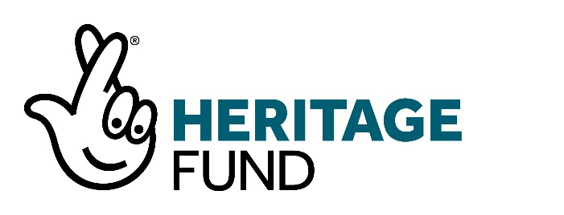
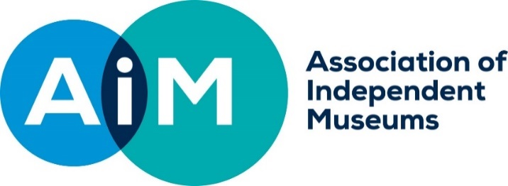

NEW STORIES NEW AUDIENCES
APPLICATION GUIDANCE

- INTRODUCTION
Funded by National Lottery Heritage Fund, AIM’s New Stories New Audiences scheme offers grants of up £15,000 to AIM’s smaller members to deliver projects that tell a new story that will attract a new audience for their organisation.
We will support museums to work with new partners and try out something new.

We know that all museums need to increase and widen their audiences to enhance their sustainability and to widen participation to groups that are currently under-represented. We want New Stories New Audiences to inspire museums to stay relevant to their audiences and to increase their impact.

This guidance tells you more about the programme and the types of projects we will fund.

- WHO CAN APPLY?
The programme is open to all AIM members in the small museums’ category (up to 20,000 visitors). These can be not-for-profit organisations or private owners of heritage.
We will ask to see your constitution or governing document.
If you are a private owner, we will assess whether public benefit outweighs any private gain so please consider this in your application.

- WHAT CAN WE FUND?
We will fund projects that result in a wider range of people being involved in heritage at your organisation. We expect that you will have identified a new story that you wish to tell, that you have undertaken some initial research to identify who the new audience will be, that you will work with a new partner to develop the story and that your project will mean that you work differently and try something new.
If your application is successful, we will give you support to further develop and deliver your project.

See section 11.1 If your application is successful.

3.1 TYPES OF PROJECTS
As an example, these are some of the successful projects funded in round 1 (2021):

Provan Hall received £15,000 to collaborate and create an educational resource with local communities to interpret their built heritage and history.

The Museum of Youth Culture received £14,500 for a project working with young people from Hackney’s Black African and Caribbean communities to collect stories, curate and produce an exhibition.

The Scottish Fisheries Museum received £11,896 to create a touring exhibition and series of activities to showcase island life in the Forth, including climate change impacts.

Edeyrnion Heritage and Cultural Society (Corwen) received £18,825 for a project designed to bring together a deprived rural community with an immersive display, bilingual walks, outdoor interpretation boards, in person guided walks and a launch event, all centred around local heritage and landscape.

Birkenhead Priory received £11,600 to develop a 3D tour of the grounds and learning resources for KS1 and 2, collaborating with the area’s multi-faith communities and schools.

Sturminster Heritage Trust received £14,000 to work with young people in Sturminster and in Newfoundland to the explore history of people emigrating to Canada from the 1600s to the 1800s.

We will only fund projects that:
- Have a clear plan with a defined start, middle and end
- Have not already started
- Will last up to one year

3.2 WORKING WITH A NEW PARTNER
Working with a new partner to develop a resource is often called co-creation or co-curation. It is the practice of involving people in the making of anything a museum can produce. The people involved might be individuals or belong to a community group or another organisation. It is important to remember that co-creation should be a collaborative process about sharing power. The partner that you work with should have an equal voice in decision making.

Examples of partners could include a school, local history group, university, local charity, community, social or volunteer groups or individuals such as artists.

3.3 IDENTIFYING A NEW AUDIENCE
You need to know something about your existing audience and have identified an audience that is currently under-represented.

We would like to support organisations that recognise their responsibility to carry out their purpose for the benefit of all, striving to make a positive impact and represent all communities. Inequalities exist across society and can be perpetuated by organisations (often unconsciously or through a lack of awareness) when they work in ways that disadvantage or discriminate against people.

Examples of new audiences could include members of BAME communities, people with a disability, young people, or local people from particular socio-economic groups.

This is outlined in AIM’s new Tackling Inequality Hallmark
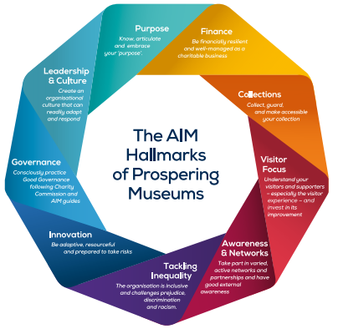
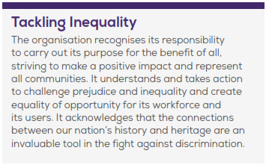

  - TELLING A NEW STORY
Museums specifically have a unique opportunity to use and develop their collections to highlight discrimination, identify and address missing perspectives and encourage debate and discussion. You’ll need to find what may spark non-visitors’ interest from among your assets, i.e. collections, sites, stories of which you are the custodians. It is a good idea to consult people from those groups to uncover which hidden aspects of a museum’s collection, history or site may encourage them to visit and explore further.
Your new story could be related to your local area, mission, groups, individuals from the past or present that you do not currently explore.

For example:
The family that owned a historic hall founded an American state which enslaved Africans. The museum has identified that the current family-focussed interpretation could be rewritten to incorporate the role they played in the perpetuation of slavery.
A town centre museum holds a collection of furniture made by slaves and imported from the West Indies so a new project could explore the town’s history as a slave port.
A museum is dedicated to an artist who lost the sight in one of his eyes. This provides a link with visually impaired artists and the potential to widen the venue’s appeal through new interpretation or a temporary exhibition on the subject.

- ELIGIBLE COSTS
We can cover a wide range of direct project costs. As an example, your project could include:
- Volunteer expenses
- Training costs
- Event costs (including room hire, refreshments and equipment)
- Small capital works (including purchase of equipment, digitisation and minor building work)
- Costs to improve access
- Professional fees
- Interpretation and display costs

We cannot cover the following:
- Staff posts
- Statutory and legal responsibilities
- Promoting the cause or beliefs of political or faith organisations
- Recoverable VAT
- Costs for any activity that has taken place before a grant is awarded
- Purchasing heritage items or collections
- Conservation

- OUTCOMES
Outcomes are changes, impacts, or benefits that happen as a direct result of your project. All projects must achieve the first outcome and one other.
- A wider range of people will be involved in heritage (mandatory outcome)
- Heritage will be better identified and better explained
- People will have developed skills
- People will have learnt about heritage leading to change in idea and actions
- People will have greater well-being
- The funded organisation will be more resilient
- The local area will be a better place to live, work or visit

- ENVIRONMENTAL IMPACT
You will need to consider how to make your project more sustainable by increasing positive environmental impacts and reducing negative impacts and should embed this into your project from the beginning.
The measures that you implement should be appropriate for the scale of your project. Measures could include:
- Using recycled materials and products e.g. paper
- Encouraging sustainable travel e.g. bus or train, walking and cycling
- Telling visitors how the organisation is adapting to climate change and environmental measures used on the site
- Reducing energy use (more efficient heating, LED lighting, better control systems) and using renewable energy or energy generated on site
- Reducing use of plastics, especially single use plastics
- Reducing waste produced on site/having an effective recycling policy

- PROMOTION OF YOUR NEW STORIES NEW AUDIENCE GRANT
All grant holders must acknowledge the support of AIM and National Lottery Heritage Fund publicly. They must do this for the duration of the grant contract.

- Signage – we require you to display plaques showing our logo at every main customer entrance and exit and every facility and exhibition funded by AIM and the National Lottery Heritage Fund.
- Online and social media including websites, blogs, and apps. Social posts should include @Aimuseums, @HeritageFundUK and #NationalLotteryHeritageFund
- Promotional material and publications e.g. leaflets, newsletters, posters, guidebooks, annual reports etc
- Press releases about work funded by AIM and the National Lottery Heritage Fund must also bear our logo, as well as acknowledging our support in the text
- Events - Your AIM and National Lottery Heritage Fund grant must be acknowledged at any event that relates to an activity we have funded.

We also expect you to develop innovative and creative offers or promotions designed to thank National Lottery players for their support and to raise awareness of your funding.

Full guidelines and the correct logos will be supplied to successful projects.

- EVALUATION
We will ask you to take part in our project evaluation from the beginning of your project.
This will include collecting quantitative and qualitative information including:
- number of visitors before and after the project
- the number of people involved in the project (and demographic information)
- volunteer hours
- the impact on the organisation and partners
- how the project has met the outcomes you identified
- how you worked with a new partner and the impact this has had
- long term benefits and the impact on the organisation as a whole.

- YOUR CONTRIBUTION
We ask that you contribute at least 5% of your project costs. We describe this contribution as ‘partnership funding’ and it can be made up of cash, non-cash contributions, volunteer time or a combination of all of these.

CASH CONTRIBUTIONS
This might be from your organisation’s own reserves, a donation from a benefactor, a grant from another funder or other fundraised support (for example, crowd funding).

NON-CASH CONTRIBUTIONS
This includes anything you need for your project that you do not have to pay for (for example, room hire or equipment). We can only accept non-cash contributions if they are direct project costs that could have been part of your project budget.

VOLUNTEER TIME
This is the time that volunteers give to support the delivery of your project. This could include administrative work, clearing a site or working as a steward at an event. You should not include costs for the time of people who will take part in your activities (for example, people who attend a workshop or go on a guided tour).
We use a standard rate to calculate the value of your volunteer time:
- Professional volunteer (for example, accountancy or teaching) £50 per hour
- Skilled volunteer (for example, leading a guided walk) £20 per hour
- Volunteer (for example, clearing a site or acting as a steward at an event) £10 per hour
The total cost of your project will be the amount of cash grant you are applying for plus your contribution.
For example:
Cash grant - £15,000
Your contribution - £750
Total project cost - £15,750

10 APPLICATION PROCESS
10.1 TIMETABLE:
- Grant scheme opens – June 2022
- Complete our online eligibility check
- Closing date for applications – 31 October 2022
- Grant panel meets and grants awarded – December 2022
- Notification of successful projects and formal offer letters – January 2023
- Projects to be completed with 12 months of formal offer letter – January 2024

10.2 HOW WE ASSESS YOUR APPLICATION
Applications to New Stories New Audiences will be assessed against the following criteria:
- Mandatory outcome, that the project will result in a wider range of people being involved in heritage at the organisation and at least one other NLHF outcome from the following
  - Heritage will be better identified and better explained
  - People will have developed skills
  - People will have learnt about heritage leading to change in idea and actions
  - People will have greater well-being
  - The funded organization will be more resilient
  - The local area will be a better place to live, work or visit
- The organisation has identified a new story that it wishes to tell
- There is an understanding, based on initial research, of who the new audience(s) for the new story will be
- The organisation has identified at least one new partner / group to work with in developing the story
- The organisation explains how it is keen to work differently, innovate and learn new skills
- The project is deliverable within the parameters of the programme and shows value for money

10.3 SUPPORTING DOCUMENTS
You will need to submit the following supporting documents:

- Governing document (for example, constitution)
We do not need to see your governing document if:
- You are a public organisation (for example, a local authority)
- You are a private owner of heritage

- Accounts
Include your most recent audited or accountant verified accounts.
If you are a newly formed organisation and do not have a set of audited accounts, please submit your last three bank statements or a letter from your bank confirming that you have opened an account.
We do not need your accounts if you are a public organisation (or example, a local authority)

- Briefs for externally commissioned work over £10,000
Briefs describe any work you plan to commission during your project. If you are commissioning work (for example from an artist or architect) then you should submit a brief.
The brief should describe the works, how long they will take, how much they will cost, and the skills required.

- Letters of support (no more than six, if applicable)
Letters of support are a good way of showing us that you have spoken to other people and that they are interested and committed to your project.
Please send us letters of support from the people involved in your project, rather than general supportive statements. For example, if you are planning to deliver workshops at local youth clubs then a letter of support will show us that they want to take part.

- WHAT HAPPENS AFTER YOU APPLY?

11.1 IF YOUR APPLICATION IS SUCCESSFUL:
We will contact you within a week of the grant panel meeting. We will send you a formal grant offer letter with terms and conditions of the grant. You will need to sign this and return it to us with your bank details. When these have been returned the first payment can be made.

Payment terms
Your will receive 80% of your grant up front and the remaining 20% on completion of your project.

Reporting
We will ask you to provide a mid-term and an end of project report with a brief summary of expenditure and corresponding invoices.

Terms of grant
We will ask you to sign up to our standard terms of grant (separate document).

Supporting you deliver your project
Successful projects will be allocated an experienced project mentor who will provide support and advice in areas such as: understanding and developing your audiences, community engagement, diversity and inclusion, partnership working and co-creation.

You will also take part in the New Stories New Audiences network with other successful applicants. At the end of your project you will be brought together to share learning, contribute to the evaluation of the experience, and inform the creation of new resources.

11.2 IF YOUR APPLICATION IS UNSUCCESSFUL:

If your project was not awarded a grant, we will give you feedback on the reason for this. You may be invited to resubmit your application in a further round.

- HELP WITH DEVELOPING YOUR PROJECT
Please talk to us while you are developing your project.
We will tell you whether your project is eligible and help you make your application as strong as possible.

You can also sign up for one of our online Hallmarks at Home workshops on developing a New Stories New Audiences application.
We will provide information on all aspects of the scheme and there will be an opportunity to ask questions about your application.

Useful resources to help you develop a project:
http://sharemuseumseast.org.uk/wp-content/uploads/2013/08/Co-creating-Community-Projects.pdf
https://www.artscouncil.org.uk/advice-and-guidance/inspiring-learning-all-home-page
http://ourmuseum.org.uk/?welcome=1
http://www.openupmuseums.com/

- LEGAL AND POLICY REQUIREMENTS
13.1 OWNERSHIP REQUIREMENTS
We expect you to own any property (land, buildings, heritage items or intellectual property) on which you spend the grant.
If you do not own the property, we will consider support for projects where a minimum of 10 years tenure or loan has been agreed. In these cases, it may be necessary for the landlord to be contracted in as a party to the agreement.

  - DIGITAL OUTPUTS
We have specific requirements, which are set out in our Standard terms of grant, for ‘digital outputs’ produced as part of any project.

We are using the term ‘digital output’ to cover anything you create in your project in a digital format that is designed to give access to heritage or to help people engage with and learn about heritage.

For example, this could be digital images, sound files or data, a website with heritage material, an app, virtual reality, or a film made using digital technology.

The requirements do not apply to digital outputs that have no heritage content or do not engage people with heritage, for example, a website that contains only information about your organisation/ project or events listings.

All digital outputs must be:
- ‘Usable’ (the output functions as intended and is kept up-to-date) and ‘available’ (the output is available to the public as intended; all the digital files are held securely; you can give access to the digital files on demand) for five years from project completion.
- Free of charge for non-commercial uses for five years from the the Project Completion Date.
- Llicensed for use by others under the Creative Commons licence ‘Attribution Non-commercial’ (CC BY-NC) for five years from the Project Completion Date, unless we have agreed otherwise

