TRUSTEE RECRUITMENT PACK
Higher Mill Museum Trust

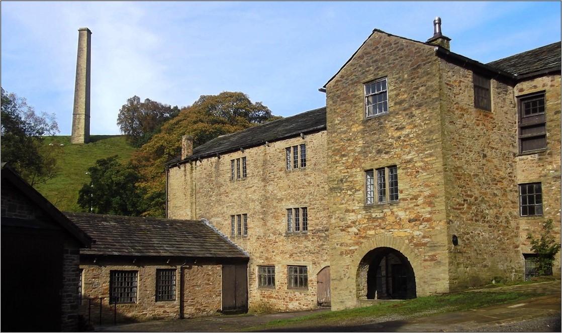
Higher Mill

Welcome by Bernard Rostron, Chair of Trustees of Higher Mill Museum Trust
Welcome to Higher Mill Museum Trust (HMMT). We are delighted you have taken an interest in joining us as a Board member.
We are looking for Trustees to develop further the current Trustee team and to bring new skills and strengthen the governance of our charity.
The Trust is an independent charity responsible for preserving and protecting Higher Mill, a listed wool fulling mill within the Helmshore Mills Textile Museums complex. It is the private landlord of the 1789 working mill, its surrounding land, mill ponds and water wheel. The site is managed, maintained and opened to the public by Lancashire County Council Museums Service on the HMMT’s behalf.
The Trust is focused on achieving its mission of promoting the mill museum as a heritage visitor attraction, increasing its status as an industrial museum of major significance, and supporting learning programmes for schools and education groups run by the local authority. These heritage and educational purposes underpin all that HMMT does.
Below, you will read more information about us, what we do, and who we are. If you have any questions and would like to know more, please contact us. We would be happy to give you further information as you need it.
HMMT is an exceptional organisation, which I am proud to be associated with. The Board members’ hard work is committed to securing the long-term viability and success of the Trust.
As the Chair, I would welcome the opportunity to talk with potential candidates. You can contact me via rostronb@gmail.com.
Early expressions of interest are warmly welcomed.

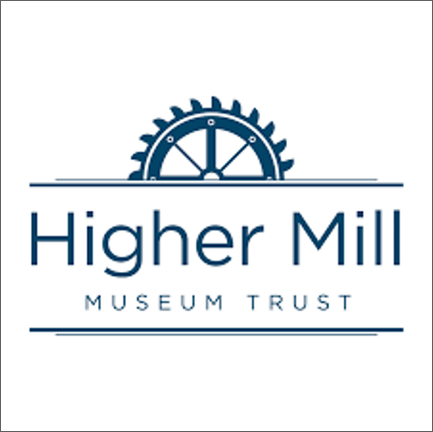

Background to Higher Mill and HMMT
This 18th century fulling mill, which we now know as Higher Mill, was built on land acquired by the Turner family in 1789. The site is nationally recognised with the status of a Scheduled Ancient Monument.
The mill is located in Helmshore which lies in the Rossendale valley north of Manchester. Helmshore is relatively close to other towns famous for their textile heritage such as Burnley, Bury, and Bolton.
Higher Mill processed locally woven wool cloth. In 1820 the son of one of the founders, William Turner (1793 - 1852), took control of the enterprise and on the same site added a larger mill building (now known as Whitaker Mill) dedicated to weaving wool cloth. The wool processing mill is a unique survivor in East Lancashire, which had a mix of both wool and cotton mills, while the rest of Lancashire is more closely associated with cotton yarn and cloth production.
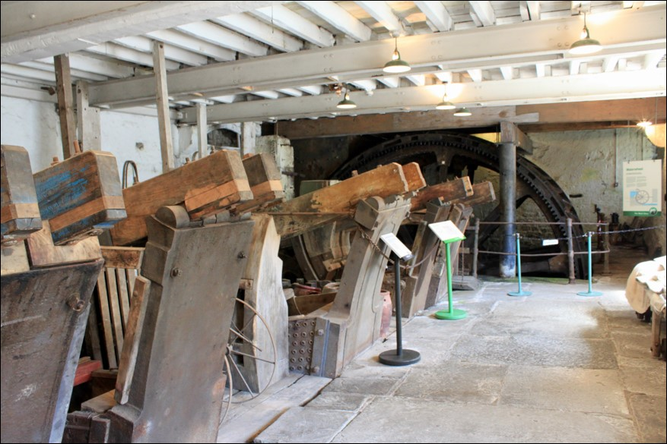
Higher Mill fulling stocks
In 1875 Higher Mill came into the ownership of Lawrence Whitaker, and the Whitaker family continued to operate it as a fulling mill. Little was changed over the ensuing 90 years so that when production ceased in 1967 some of the original machinery introduced by William Turner was still working.
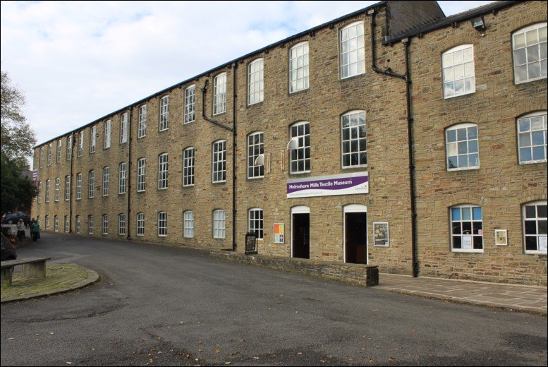
Whitaker Mill
The waterwheel and fulling stocks are still operational, and the Trust hopes to be able to re-instate the shafting needed to drive the rest of the Mill’s machinery from the waterwheel. Sadly, the mill pond has been drained temporarily, to facilitate restoration work on the waterwheel.
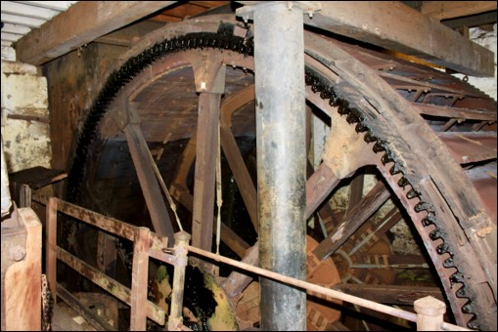
Together, Higher Mill, Whitaker Mill, the mill ponds and the waterwheel now constitute the Helmshore Mills Textile Museum, administered and staffed by the Lancashire County Council Museum Service. A much-loved visitor attraction, the Museum is featured in ‘Looms with a View’, a Lancashire heritage tour proposed by The Guardian in summer 2023: it “recounts the stories of the woollen and cotton industries through an original waterwheel, carding engines and spinning mules, and child-friendly interactive displays.
At the former Wavell Mill on Holcombe Road, note the blue plaque commemorating the power loom riots of 1826, when workers fearful of losing their jobs attacked new-fangled machinery with hammers and picks”. See https://www.theguardian.com/travel/2023/jun/29/looms-with-a-view-tour-lancashire-former-mill-towns-british-textile-biennial.
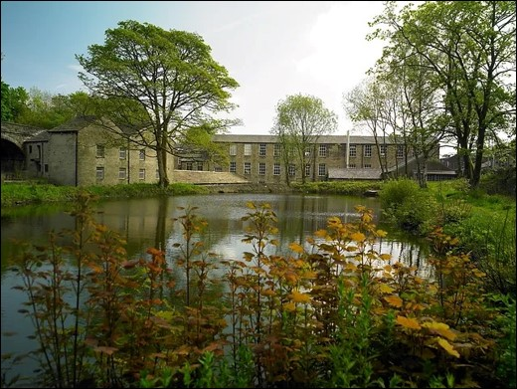
Higher Mill Lodge
The Trust continues to own Higher Mill and maintains a close working relationship with the Museum Service as well as with the Museum’s Friends organisation which numbers about 100 members.
The charity, the Higher Mill Museum Trust, was formed in 1967. Its founding Trustees included Professor Owen Ashmore F.S.A. (author of “Industrial Archaeology of Lancashire”) and Dr.Sir Rhodes Boyson, a headteacher who was a historian and at one time an MP and Government Education Minister. In 1975, the Trust agreed a 99-year full repairing lease signed with Lancashire County Council at a peppercorn rent. In 1978, the Whitaker Mill closed commercial operation. Whitaker Mill and Higher Mill became The Museum of the Lancashire Textile Industry later renamed Helmshore Mills Textile Museums.
In 2018, the Higher Mill Museum Trust became a Charitable Incorporated Organisation (CIO), offering the standard benefits of incorporation and limited liability to its Trustees.
The Trust believes that the future can best be achieved through radical and dramatic improvements in the way in which the building and its artefacts are presented. The Museum needs to respond to the needs of today’s and future audiences.
Sustainability means significant improvement, investment, and public support. Public support is a vital element in applying for improvement grants evidenced as interest groups and as financial contributions towards match funding.
quotation/s from Tripadvisor:
“Amazing visit to Helmshore Textile Museum, we had a brilliant time, it is such a fascinating place with a rich and varied history”.
“We were a family group visiting the area for a reunion plus the chance to explore our family history. Our great grandfather had worked in a mill as had other relatives so the chance to visit the museum with its working machinery was too good to miss”.
“It was so interesting to see the working machinery and learn the intricacies of cotton and wool production alongside the social and working conditions of the time. Highly recommend this museum. One of the best in Britain!”
“Had a really enjoyable afternoon at this fascinating industrial heritage museum. The guides were very knowledgeable and friendly. The tours were excellent, demonstrations of working machinery included, they really made it come to life”.]
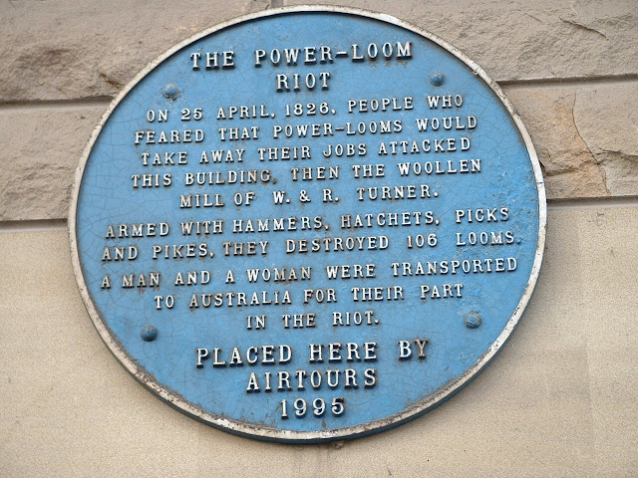
Blue plaque commemorating 1826 power loom riot at Wavell Mill, Turner’s Middle Mill

Mission, Vision and Charitable Objects of HMMT
The mission of the Trust is to “protect and preserve the historic buildings and grounds which make up this scheduled monument as a working museum, enhanced with collections relevant to its history. We will ensure that both staff and volunteers fully understand and meet the needs of visitors, be they adult or child, and be their visit recreational or educational. We will ensure that the museum maximises all suitable financial, professional and voluntary skill resources and opportunities. We will work in partnership with Whitaker Mill to enhance the significance and success of the combined Helmshore Mills Textile Museums.”
Our vision statement is: “We envisage a successful and authentic heritage attraction, where collections, housed in a preserved monument and site, will continue to attract, educate and inspire future generations.”
The charitable Objects of the Trust are:
1. the preservation and conservation of Higher Mill Helmshore and the associated land as a site of significant historical and architectural interest.
2. the advancement of education in the subject of textile industry by all or any of the following means:
i) the use of Higher Mill as a working museum of the Lancashire textile industry to promote textile heritage, education and public access.
ii) the acquisition, preservation and interpretation of early textile machines and relevant collections for display to the public in Higher Mill or any other museum.
iii) the promotion of the study of, and research into, the history of the textile industry and the publication of the results of such study and research.

Role of the Board and its Trustees
The Board at present has seven members. Board members serve a three-year term and can be re-elected.
The Board seeks to follow good governance practice as set out in the Charity Governance Code for England & Wales.

Skills of a Trustee
In the annex to this pack there is a full role description and person specification for Trustees. Please read this fully and reflect on whether you meet the person specification.
The Board anticipates applicants will be able to offer:
- Ability to focus on issues requiring action, including fresh ways of looking for sustainable solutions;
- Demonstrate a willingness to learn;
- Sound independent judgement and commitment to work as a member of a team;
- A willingness to share their networks to help the Trust.

Remuneration
This is a voluntary position with the reimbursement of agreed travel and out of pocket expenses incurred.

Benefits of being a Board member
There are lots of reasons why individuals want to join Boards and enjoy working with other Board Members. You may have your own reasons to add to these benefits that others tell us about:
- It provides me with intellectual and emotional challenge - stretching me, drawing on my intellectual and emotional “muscles” and providing me with a sense of self- esteem and satisfaction.
- It gives me the opportunity to “give back” - I feel good when I have seen myself contribute to the growth and success of an organisation that is benefitting the community and others as well as myself.
- It has helped to support my career development - I can develop new skills, experience and competencies that have enriched me.
- I have learnt new skills by working with people who I would not usually work with, this broadens my horizons and ideas about ways of doing things.
- It has given me more opportunities for networking, and it has expanded my spheres of influence, I enjoy being in other Board members’ company.

Board members’ duties and behaviours
Board members have, and need to accept, ultimate responsibility for directing the affairs of the organisation, ensuring that it is solvent and well-run, and delivering the outcomes for the benefit of the public for which it was set up.
We would expect all Board members to abide by recognised codes of good behaviour, such as those provided by the Charity Governance Code.

Time commitment
You should give enough time, thought and energy to the role of Trustee, for example, by preparing for, attending and actively participating in all trustees’ meetings.
We recognise that people have different demands on their time. The commitment can be summarised as:
- Five board meetings a year, [one of which includes the Annual General Meeting], each lasting around two hours, normally held on Wednesday afternoon [this is currently under review
- As and when required, undertake specific research or participation in discrete working groups created on a short-term basis.
- Trustees are encouraged to support the Trust by attending events and exhibitions.

Who can be a Board member?
All applicants must be 18 years of age or over.
Those who would be disqualified from being a Board member of HMMT include:
- Anyone who has an unspent conviction for an offence involving deception or dishonesty.
- Anyone who is an undischarged bankrupt.
- Anyone who has been removed from Trusteeship of a charity by the Courts or Charity Commission for misconduct or mismanagement.
- Anyone who is disqualified from being a company director under the Company Directors Disqualification Act 1986.

Our application and selection process
If you feel you can step up to the role of Trustee, we very much welcome your application. We would strongly encourage you to have an informal discussion with the Chair before formally applying.
When you apply, please send your application to Bernard Rostron at rostronb@gmail.com. It should include:
- a short statement explaining why you would like to be a Trustee of HMMT
- a maximum 2 sides CV setting out your relevant knowledge, skills and experience for the role of Trustee of HMMT
- the names and contact details of two referees who HMMT may speak with
In the event of multiple applications, a sub-group of the Board will agree a short list of applicants to be interviewed. All shortlisted applicants will meet individually with an selection panel of current Board members.
HMMT will write to all shortlisted applicants after the interview, explaining the outcome and the reasons for the interview panel’s decisions.

HIGHER MILL MUSEUM TRUST (HMMT)
ROLE DESCRIPTOR AND PERSON SPECIFICATION
TRUSTEE
Role Descriptor for Trustee
Primary objective
Trustees work together towards a transformation of the Higher Mill to develop the site as a leading heritage attraction on a sustainable basis, attracting finance and resources to realise that vision. Trustees will act at all times in the best interests of HMMT and those it serves.
Main role and responsibilities
Strategic direction
- To ensure that HMMT has a clear vision, mission, values and strategic direction and is focused on achieving these;
- To support the development of partnership and good working relationships with the Lancashire Museum Service team, the Friends Group and other partners;
- To oversee strategic plans and budgets and the fundraising and income generation strategies that support the vision, mission and strategy;
- To be effective stewards of HMMT’s assets, taking care over their security, and how they are used and ensuring the solvency and sustainability of HMMT;
- To ensure that there is a regular review of strategic plans and priorities, based on the assessment of performance and a changing external environment.
Performance management
- To work with fellow Trustees in evaluating and improving the effectiveness and operation of the Trust;
- To take opportunities to understand, promote, support and represent the work of HMMT by visiting the site periodically and meeting visitors, staff, and stakeholders;
- To ensure that strategy and operations protect HMMT’s financial sustainability and assets;
- To support step changes in the organisation, particularly identifying and implementing new revenue streams.
Compliance and good governance practice
- To ensure that HMMT complies with all legal and regulatory requirements, and pursues accepted good governance practice (e.g. Charity Governance Code);
- To understand and comply with the governing documents of HMMT and to review the governing documents regularly to ensure they are fit for purpose;
- To ensure that HMMT has a governance structure that is appropriate to a charity of its size, stage of development, and its charitable objects, and reflects the diversity of the visitors to Higher Mill;
- To attend Board meetings, having read and considered the agenda and papers, and able to contribute to free, open, inclusive and constructive debate and evidence based decision making;
- To ensure regular succession planning for the Board, ensuring the Board has the breadth and depth of skills it needs, and contributing to appropriate induction for all new members (e.g. offer of buddying).
Person specification for Trustee
- An enthusiasm and commitment for the work of the Trust and its objectives of its collaborations with partners;
- The ability to develop a broad, big-picture view of the Trust and its objectives and to keep mission-focused;
- Experience of having worked in or with Boards or strategic committees in charities, not for profits, statutory bodies or the private sector;
- An understanding of charity governance, including the role of Boards of Trustees;
- Ability to think creatively, particularly help the Trust attract the funding and resources it needs to realise its ambitions;
- Ability to maintain an independent perspective, and with no significant conflicts of interest, and to exercise sound and independent judgement;
- Ability to communicate clearly and sensitively and to take an active part in discussions, expressing their own opinion in a reasoned way;
- Ability to work effectively in a group, listening to the views of others, challenging constructively and asking questions appropriately;
- Ability to contribute the necessary time and effort that the role of a Trustee would require;
- Willingness to make and stand by collective decisions, including those which may be unpopular;
- Ability to inspire trust and have credibility with relevant opinion formers and decision-makers;
- Willingness to bring new networks, contacts and supporters to the Trust to help develop its profile locally and nationally;
- Financial literacy;
